**CS673 Software Engineering** 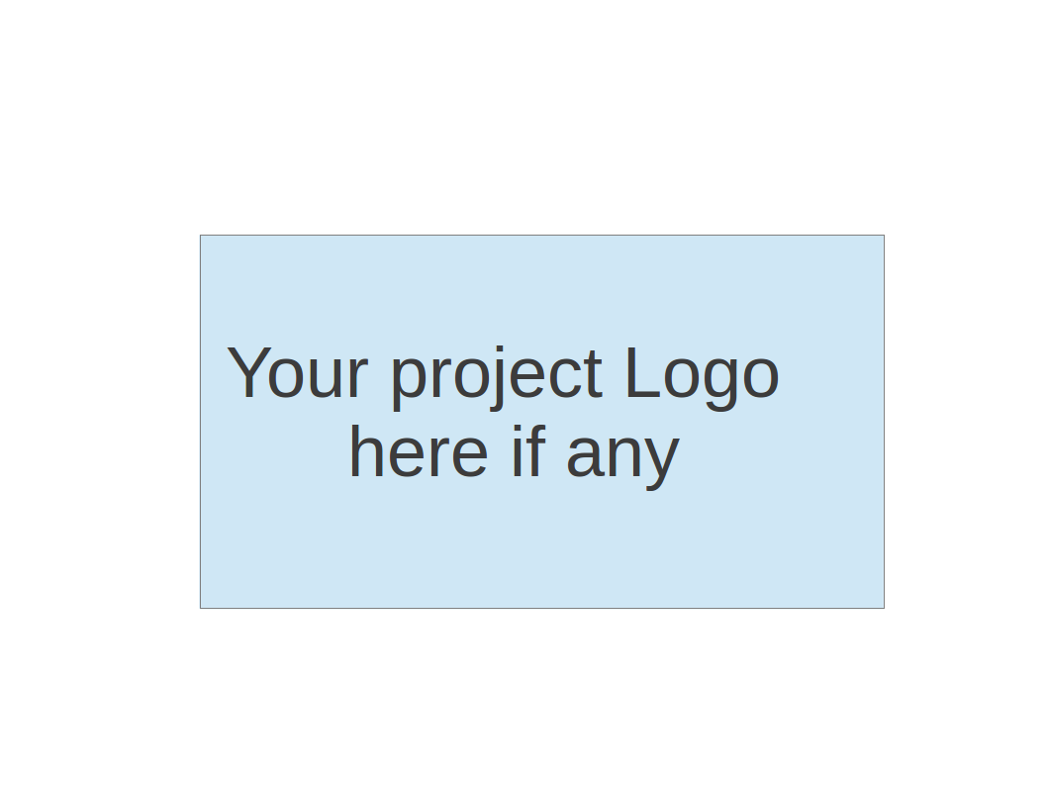

**Team 1 - Spring Alert**

**Software Test Document**

| Team Member | Role(s) | Signature | Date |
| --- | --- | --- | --- |
| Jim Penner | Team Leader | *Jim Penner* |  |
| Shenxiao (Sherry) Lee | Requirement Leader |  |  |
| Chaozheng Zhu | Configuration Leader | *Chaozheng zhu* |  |
| Hunter Washburne | QA Leader |  |  |
| Jordany Arnaud | Design & Implementation & Security leader |  |  |
|  |  |  |  |
|  |  |  |  |
|  |  |  |  |

**Revision history**

| **Version** | **Author** | **Date** | **Change** |
| --- | --- | --- | --- |
| **1** | **Jim Penner** | **05/22/24** |  |
|  |  |  |  |

Testing Summary

Manuel Tests Reports

Automated Testing Reports

Testing Metrics

References

Glossary

# Testing Summary

In this section, you will summarize what was tested, who is involved in testing, testing techniques used, and testing result. You may have the following tests

* + Unit Testing - JUnit is being used as we are working in Java
  + Integration testing - I believe Citrus was mentioned.
  + System Testing - Postman was discussed and I have used Jira before
  + Acceptance Testing - This is part of Iteration2
  + Regression Testing

# Manual Testing Report

In this section, you will give a detailed description of each manual test case performed and the result. If this is a previous You shall list what are existing tests developed in the previous semester and what are new tests developed currently.

Here is a sample template that can be used for each test case. For system tests or acceptance tests, you may also include some screenshots.

* Test case ID, name
* New or old:
* Test items: (what do you test )
* Test priority (high/medium/low)
* Dependencies (to other test case/requirement if any):
* Preconditions: (if any)
* input data:
* Test steps:
* Postconditions:
* Expected output:
* Actual output:
* Pass or Fail:
* Bug id/link: (this should link to your github issue id)
* Additional notes:

(You can use an additional spreadsheet for this section as well)

# Automated Testing Report

Describe briefly the automated testing you have done, including where the test code resides in your code repository, what test frameworks are used, and the screen shots or generated testing report.

# Testing Metrics

In this section, you shall report any metrics used for the evaluation, e.g. # of test cases, test coverage, defects rate, etc.

# References

* [A Complete Guide to Unit Testing - Software Automation Testing Consultancy Service (shiftasia.com)](https://shiftasia.com/column/a-complete-guide-to-unit-testing/)
* [Automation Testing in Agile Software Development - Software Automation Testing Consultancy Service (shiftasia.com)](https://shiftasia.com/column/automation-testing-in-agile-software-development/)
* [Automation Testing in Agile Software Development - Software Automation Testing Consultancy Service (shiftasia.com)](https://shiftasia.com/column/automation-testing-in-agile-software-development/#toc0)

# Glossary